Op Training - How Backings and toppings can make or break your embroidery!

Videos:

[Why Stabilizers matter](https://youtu.be/wSC-055q0c4)

[There's no substitute for stabilizer](https://threaducate.com/2018/08/16/theres-no-substitute-for-stabilizer/)

[Why Topping matters](https://youtu.be/Qcz7tf2Rm7I)

[3D Embroidery Topping](https://youtu.be/cUHWrQ_C6vE)

Things you will learn and start practicing after reading this:

1. How to choose the best topping and backing.
2. How to add your strategy to the ink recipe on the PO.
3. How to help keep all products in stock.

As the operator, you are making the call on what works best. If you follow these guidelines, it’ll point you in the right direction - but if something looks poor quality, I need you to creatively problem solve the correct “sandwich” of topping and backing and add your strategy to the ink recipe. This will help the next operator on the reorder pick up seamlessly and deliver the same great product!

How to add notes in ink recipe:

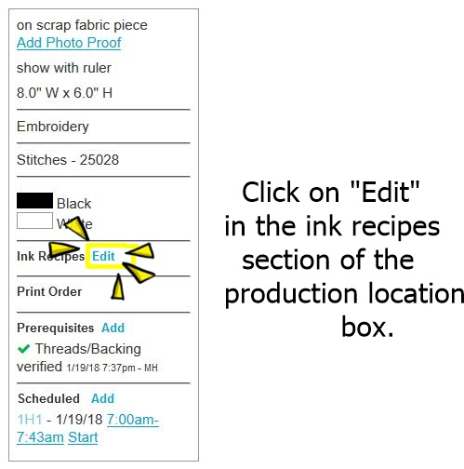

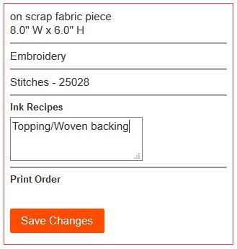

Write a brief description of what you use. For example:

Click “Save changes”.

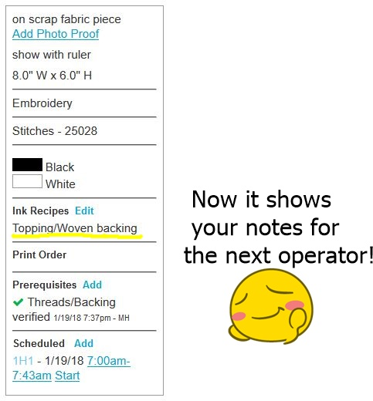

This is not just good practice, it is expected of you. **Do it every time.**

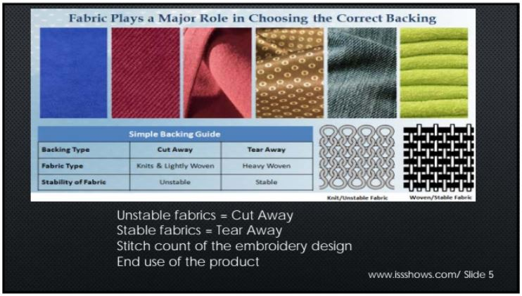

Tear away (E-ZEE Tear Crisp 1.8)

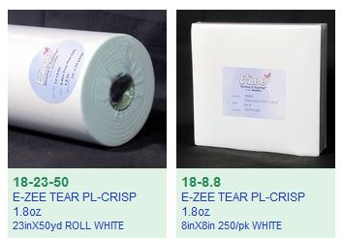

**This should be used exclusively on Non-stretch fabrics.** If a garment is stretchy - tear away can be used behind a cutaway backing but not alone. Using tear away on a stretchy fabric by itself can rip the material in the corners of the embroidery. The embroidery will also look bad after being washed.

If your embroidery has any puckering or distortion when using tear away on a non-stretch fabric,

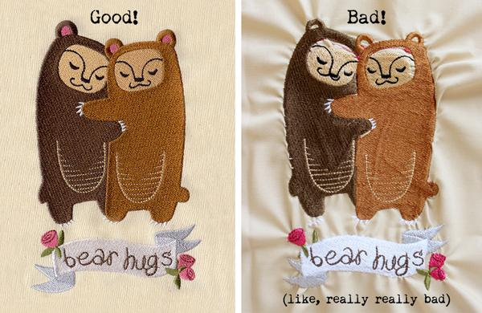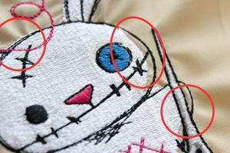

1 sheet of tear away might not be enough. Try two sheets offset from each other.

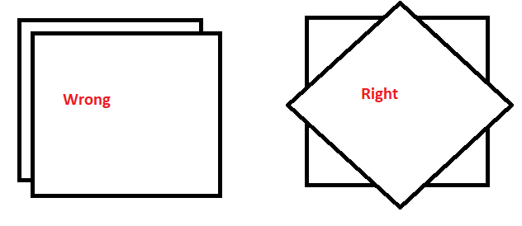

When removing the tear away, do not pull both off at the same time, pull one off and then the other!

Hat tear away (EZEE Cap 2.5)

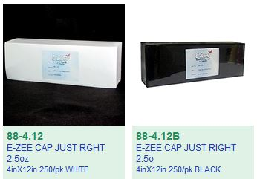

I’m going to start buying the 12 inch long backing. Cut in half and use 1 half on structured caps. Fold in half and use it double thick on unstructured hats, or use the whole piece when decorating the sides and front of the hat. Use black backing on dark hats and white backing on light colored hats.

Cutaway backings maintains the garments integrity through washes. Use on any fabric that has a stretch. If the garment’s fabric is thin, you will want to pair it with an equally thin backing. If the embroidery is particularly dense, a thicker backing might be necessary. If the cutaway backing does not provide enough structure, a tearaway backing can be added behind it for better results.

**It is not ideal to use more then 1 cut away because then it might show through the shirt.**



Thin Mesh (EZEE Weblon Noshow)

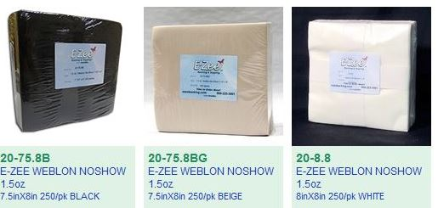

This backing is very thin 100% Nylon and best for workout performance knits and thin dress shirts. Black for dark colors, white for light colors and beige for see through garments. The beige actually blends in with skin tone.

**This is for designs under 7000 stitches.** If the embroidery has a higher stitch density try the next cutaway!

Woven Cutaway (EZEE Cut Performance)

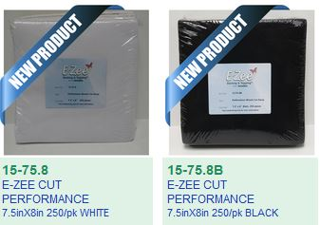

This backing feels like a thin starched woven fabric. It also works very well for dress shirts as it is thin and can handle embroidery with 8000 stitches or less. Use black for dark colors and white for lighter colored garments.

EZEE CUT 2.5 Just Right

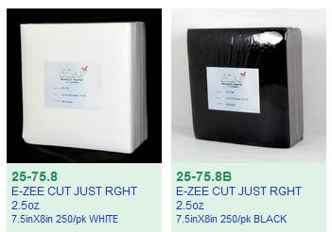

This should be your go to for cutaways. Use black on darker colors and white on lighter colors.

**Again a reminder**

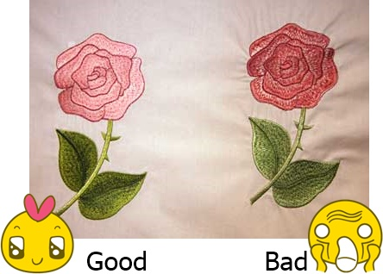

If you follow these recommendations and the backing does not give enough structure and you are having puckering, try a piece of tear away behind it or use the next thicker backing.

If the next thicker backing causes an “embroidery badge”



Then try the thinner cutaway backing but with two tearaways set at an angle from each other.



Water Soluble Topping (E-ZEE AQUA SUPREME)

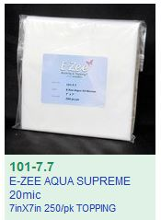

This should always be used if the fabric is shaggy (towels or fleece) or when the stitches sink into the fabric. Use it on tiny lettering. Topping can improve almost every single design, so you can never over use it. Add it on top of any troublesome embroidery design and it will help the stitches lay on top of the fabric.

3mm Foam (Do not use craft foam from craft store)

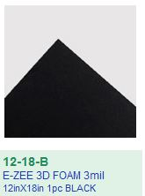

This should be cut to the size you will need and laid down after the flat embroidery is finished. You can use masking tape on the sides to hold it in place.